INFO 552: Introduction to Web Design for Information Organizations
Website Proposal: Trinket Trade Philadelphia

Submitted by: Sarah Pennebaker
May 18, 2026

Community
The proposed website Trinket Trade Philadelphia will serve local craftspeople and members of the Worldwide Sidewalk Joy community residing in and visiting Philadelphia. Trinket trading boxes are open to the public, so the website should similarly serve members of the public who are interested in beginning to trade.
Purpose
After the Sidewalk Joy trend arrived in Philadelphia in late 2025, many trinket trade and similar boxes have popped up across the city at a staggering pace (Kariuki, 2026). While the Worldwide Sidewalk Joy Project (based in Portland, OR) has a website, there is no local site for Philadelphia boxes (PDX Dinorama, 2019). The creation of this website will help the local community solve multiple issues that it is currently experiencing.
First, while some boxes have flourishing social media presences, others do not and may be difficult to locate or spread awareness on. Additionally, Philadelphia is home to many unique boxes such as the Fishtown Hot Wheels Exchange and South Philadelphia Shrek Box which are not included on the Sidewalk Joy map. Finally, many caretakers of trinket boxes across Philadelphia are in contact with each other and ask patrons to abide by the same rulesets. A centralized website is necessary for information on trinket trading rules and Philadelphia area-specific news such as press coverage or events.
Community Profile
Philadelphia trinket and art exchange boxes are run by the community for the community. These boxes are meant to spread joy and build kinship within their home neighborhoods (‌Philly Trinket Trove, 2025). Common contributors may include anyone from local artisans and hobbyists to children and families. Additionally, individuals may unintentionally happen upon trinket trade boxes while walking around Philadelphia. Information about these boxes needs to be easy to find and digest for people of all ages and technical proficiency levels.
The information on the community website should make trinket trading appealing to those new to the boxes. Basic information on what trinket trading is and why the boxes exist should be front and center in order to deter vandalism or removal. Additionally, the website needs to convey which items are appropriate to leave in the boxes: while some well-intentioned visitors have left useful items such as condoms, Narcan and (unused) tampons in the past, there are other places that provide those resources (Kariuki, 2026). These boxes are meant to “offer people the chance to swap small toys, stickers, tchotchkes, curios, knick-knacks and whatever items of whimsy can fit on its shelves and in its pouches (Kariuki, 2026).”
The local trinket trading community should also be able to use this website as a resource. A map of local boxes should be included so that information is not siloed to individual Instagram pages. A section of the website should be devoted to news coverage since there is currently no centralized news source on the various Philadelphia trinket trade boxes. Additionally, local artists will be encouraged to add to the boxes by including a Highlights page.
Finally, the website should serve the overarching Sidewalk Joy purpose of inspiring creativity and connection. To inspire creativity, it will include guidance on simple crafts and art projects that individuals can create in order to trade. To inspire connection beyond the boxes, the website will include information on other opportunities for trinket trading such as at Renaissance Faires, music festivals, and other events.
Design
While each of the trinket trade boxes around city has its own design aesthetic, they all appear fun and whimsical. For this site, I will make use of a bright and eye-catching color palette that attracts viewers. However, the site layout will remain simple and easy to navigate so as not to be overwhelming for young or inexperienced users.
In consideration that this website will often be viewed on mobile devices, Verdana will be used for the font as it is easily readable even at small sizes. Arial will be the fallback font because it is widely used and available on all major operating systems (CSS Web Safe Fonts, 2016). If possible, I would like to use multicolor text for page headers for a pop of fun using COLR or another font format (COLRv1 and CSS Font-Palette, 2022).
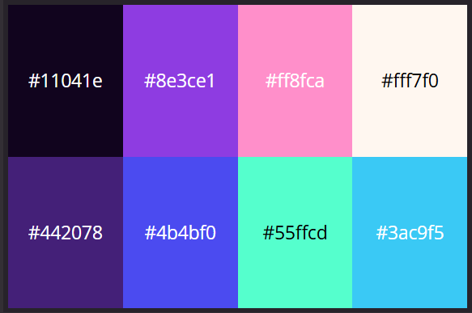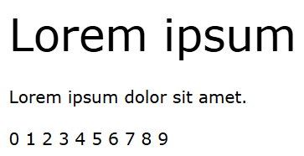
For a fun, airy look that catches the eye, I will use the Oddball Palette created by Poltergasm (Oddball Palette, 2026). This palette echoes both the purple color palette commonly used by Sidewalk Joy as well as the rainbow palette used by the Philadelphia trinket trading community Instagram pages. These colors contrast nicely and can be used for backgrounds, images, and text.
Benefits
In sum, the Trinket Trade Philadelphia website will serve as a landing place and hub for local trinket and art exchange boxes. Newcomers will learn about why the boxes exist and how to properly interact with them. Regular traders will be able to coordinate locations, find news coverage, and see contributions by local artists. The larger community will benefit by finding additional trinket trade opportunities and inspiration to craft their own contributions.
Proposed Site Map
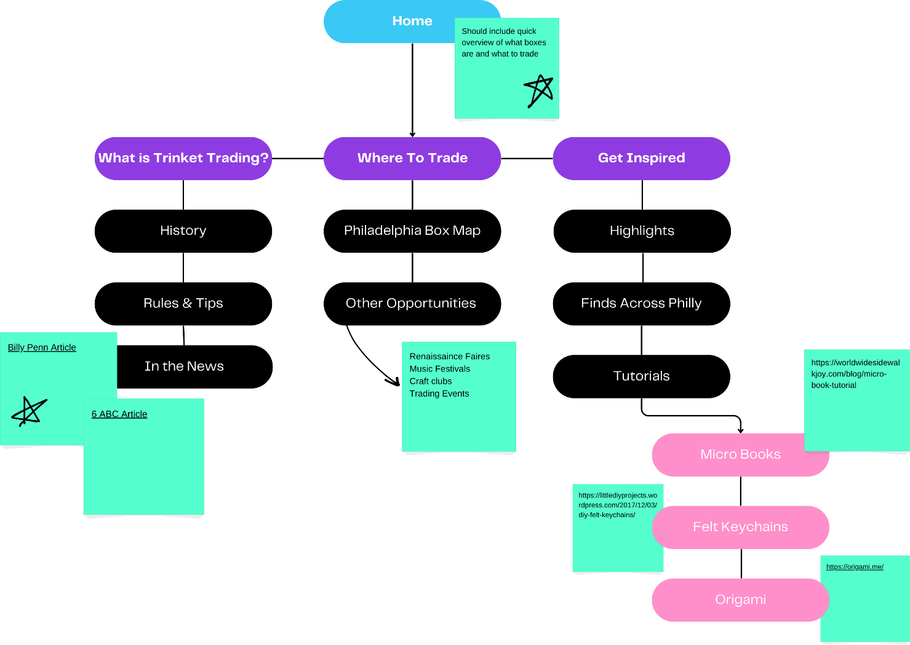

References
COLRv1 and CSS font-palette. (2022, May 11). CSS-Tricks. https://css-tricks.com/colrv1-and-css-font-palette-web-typography/
CSS Web Safe Fonts. (2016). W3 Schools. https://www.w3schools.com/cssref/css_websafe_fonts.php
Kariuki, N. (2026, March 20). How Philly Trinket Trove is inspiring joy, one small item at a time. Billy Penn at WHYY. https://billypenn.com/2026/03/20/philly-trinket-trove-south-street-grad-hospital/?utm_source=ig&utm_medium=social&utm_content=link_in_bio&fbclid=PAZXh0bgNhZW0CMTEAc3J0YwZhcHBfaWQPOTM2NjE5NzQzMzkyNDU5AAGn0MkPUgc-VcojEZIaQYVPxb6m1ajmmihbS20QksdbjbsjwnANKAR_LI6K-sI_aem_n7HPDpjEtsZyADtZRbR1Jg
‌ PDX Dinorama. (2019). About. Worldwide Sidewalk Joy. https://worldwidesidewalkjoy.com/about-me
‌Philly Trinket Trove (15th & South Street) (@phillytrinkettrove) • Instagram photos and videos. (2025). Instagram.Com. https://www.instagram.com/phillytrinkettrove/
‌
‌
‌

